

**NAME:- PATHAN HUSSAIN KHAN**

**REG.NO:-192111400**

**COURSE.CODE:-CSA1118**

**COURSE.NAME:-OBJECT ORIENTED ANALYSIS AND DESIGN**

**EXPERIMENT-1:-**

**AIM:-** To implement UML diagrams for passport management system.

**DESIGNS:-**

**1.USE-CASE:-**

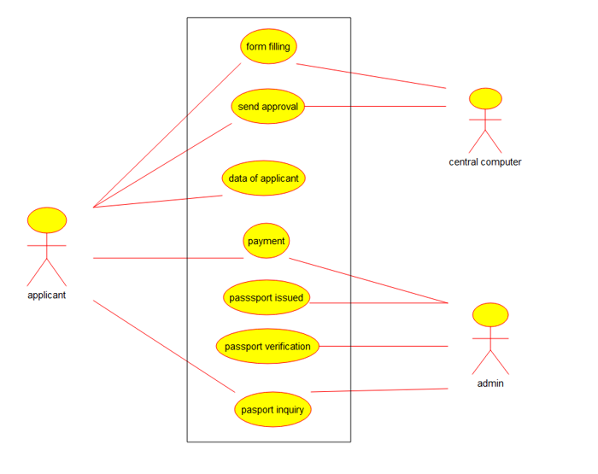

**2.CLASS-DIAGRAM:-**

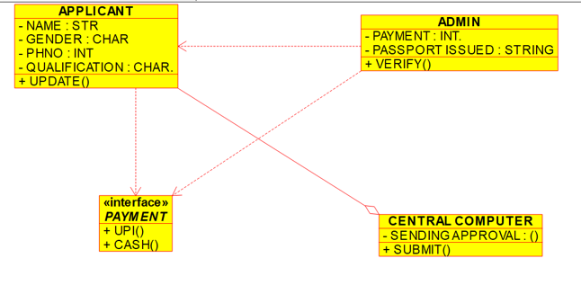

**3.PACKAGE-DIAGRAM:-**

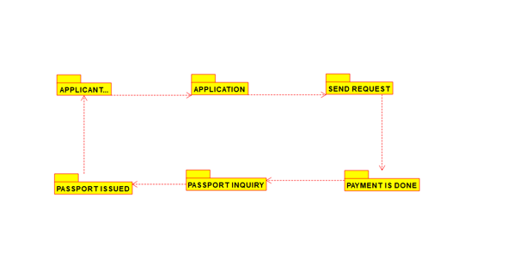

**RESULT:-**The uml diagrams of program was executed successfully by using umbrello.

**EXPERIMENT-2:-**

**AIM:-** To implement UML diagrams for BANK BOOK PROCESS.

**DESIGNS:-**

**1.USE-CASE DIAGRAM:-**

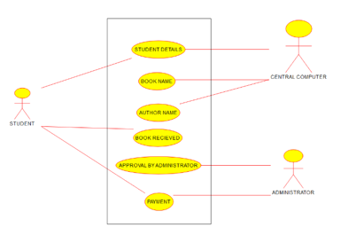

**2.COLLABORATION DIAGRAM:-**

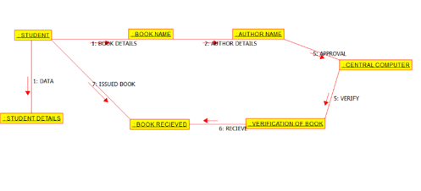

**3.DEPLOYMENT DIAGRAM:-**

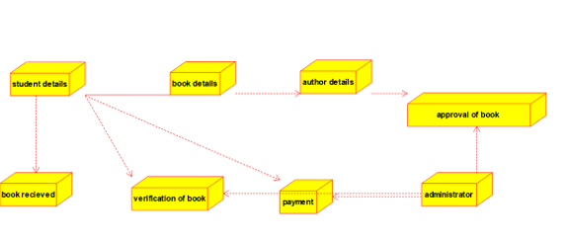

**RESULT:-** The uml diagrams of program was executed successfully by using umbrello.

**EXPERIMENT-3:-**

**AIM:-** To implement UML diagrams for EXAM REGISTRATION PORTAL.

**DESIGNS:-**

**1.PACKAGE DIAGRAM:-**

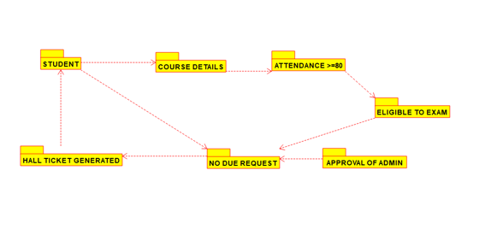

**2.COMPONENT DIAGRAM:-**

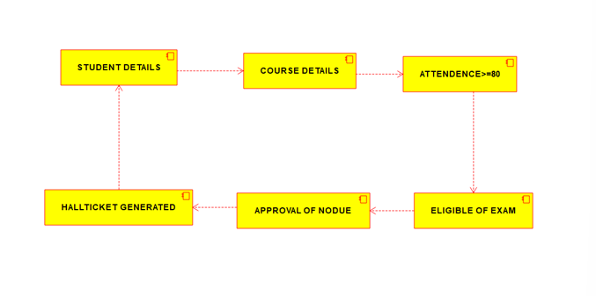

**3.USE-CASE DIAGRAM:-**

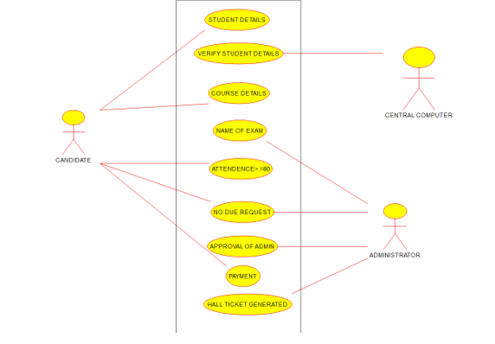

**RESULT:-** The uml diagrams of program was executed successfully by using umbrello.

**EXPERIMENT-4:-**

**AIM:-** To implement UML diagrams for STOCK MAINTAINANCE SYSTEM.

**DESIGNS:-**

**1.STATE-CHART DIAGRAM:-**

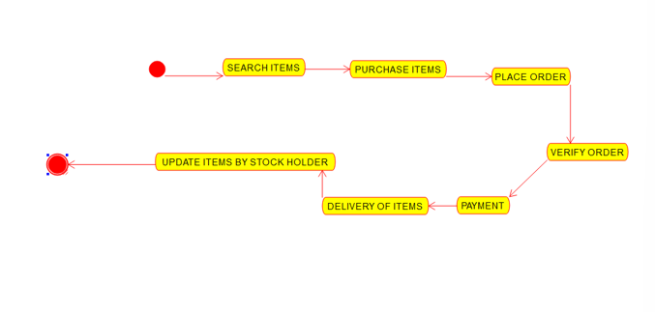

**2.DEPLOYMENT DIAGRAM:-**

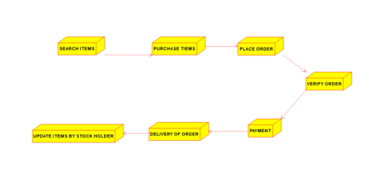

**3.PACKAGE DIAGRAM:-**

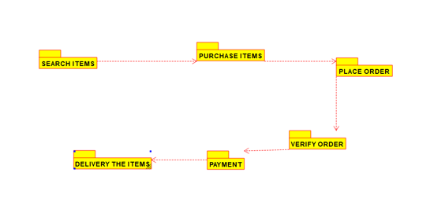

**RESULT:-** The uml diagrams of program was executed successfully by using umbrello.

**EXPERIMENT-5:-**

**AIM:-** To implement UML diagrams for ONLINE COURSE RESERVATION SYSTEM.

**DESIGNS:-**

**1.USE-CASE DIAGRAM:-**

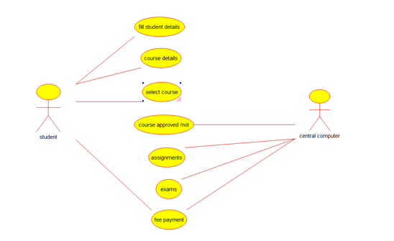

**2.COLLABORATION DIAGRAM:-**

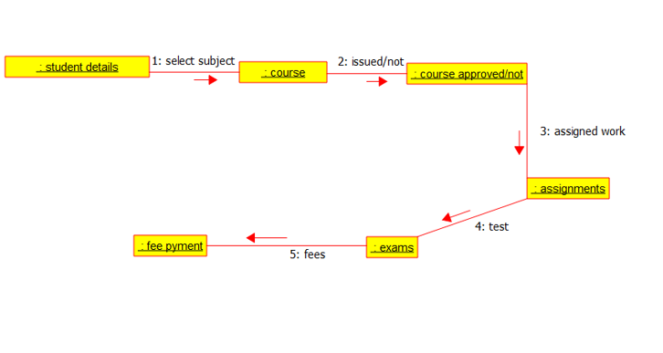

**3.ACTIVITY DIAGRAM:-**

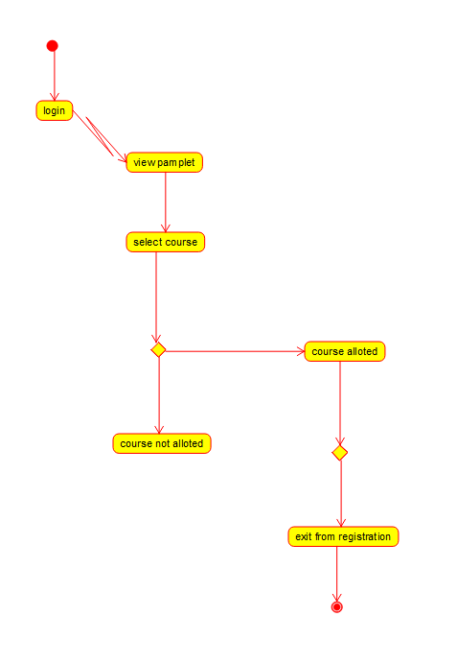

**RESULT:-** The uml diagrams of program was executed successfully by using umbrello.

**EXPERIMENT-6:-**

**AIM:-** To implement UML diagrams for E-TICKETING SYSTEM.

**DESIGNS:-**

**1.USE-CASE DIAGRAM:-**

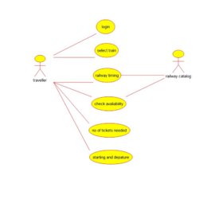

**2.ACTIVITY DIAGRAM:-**

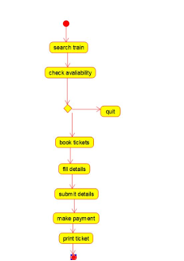

**3.COMPONENT DIAGRAM:-**

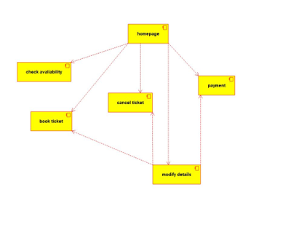

**RESULT:-** The uml diagrams of program was executed successfully by using umbrello.

**EXPERIMENT-7:-**

**AIM:-** To implement UML diagrams for CREDIT CARD PROCESSING SYSTEM.

**DESIGNS:-**

**1.CLASS-DIAGRAM:-**

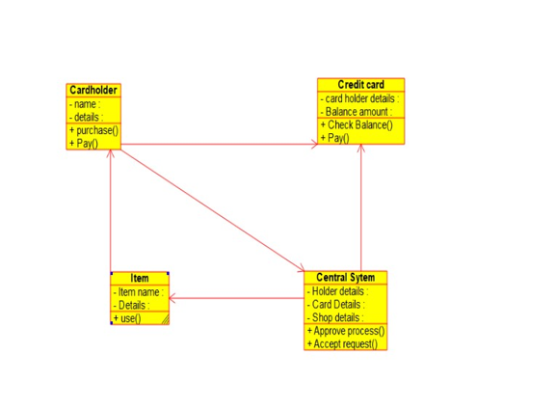

**2.ACTIVITY DIAGRAM:-**

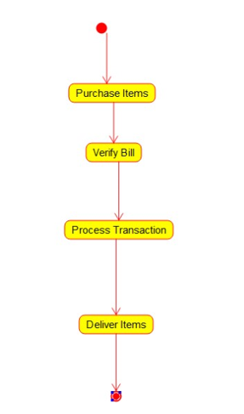

**3.COMPONENT DIAGRAM:-**

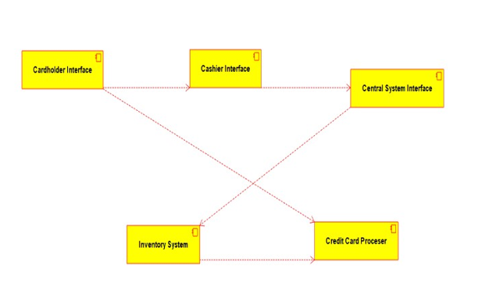

**RESULT:-** The uml diagrams of program was executed successfully by using umbrello.

**EXPERIMENT-8:-**

**AIM:-** To implement UML diagrams for Software Personnel Management SYSTEM.

**DESIGNS:-**

**1.USE-CASE DIAGRAM:-**

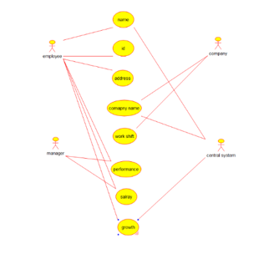

**2.COMPONENT DIAGRAM:-**

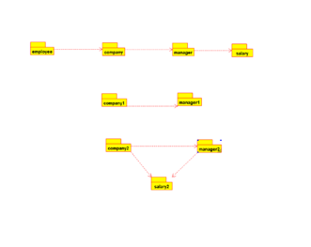

**3.COLLABORATION DIAGRAM:-**

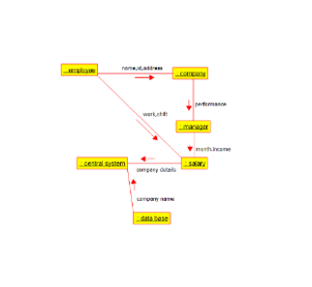

**RESULT:-** The uml diagrams of program was executed successfully by using umbrello.

**EXPERIMENT-9:-**

**AIM:-** To implement UML diagrams for E-BOOK MANAGEMENT SYSTEM.

**DESIGNS:-**

**1.USE-CASE DIAGRAM:-**

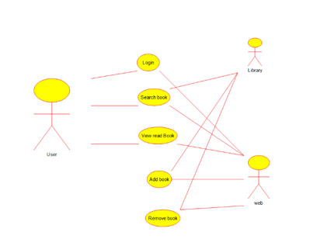

**2.CLASS DIAGRAM:-**

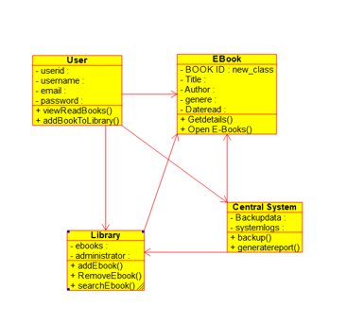

**3.ACTIVITY DIAGRAM:-**

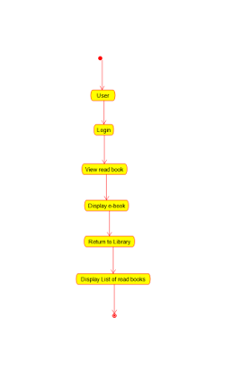

**RESULT:-** The uml diagrams of program was executed successfully by using umbrello.

**EXPERIMENT-10:-**

**AIM:-** To implement UML diagrams for SYSTEM.

**DESIGNS:-**

**1.PACKAGE DIAGRAM:-**

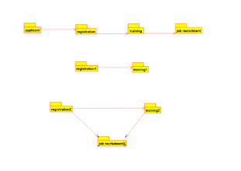

**2.DEPLOYMENT DIAGRAM:-**

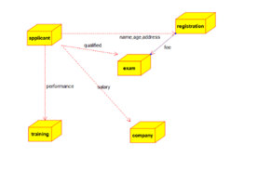

**3.COMPONENT DIAGRAM:-**

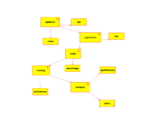

**RESULT:-** The uml diagrams of program was executed successfully by using umbrello.